Bipolar Junction Calculation HW (18 Points)
(jas, BJT Calculation HW.docx, 2/26/2024)

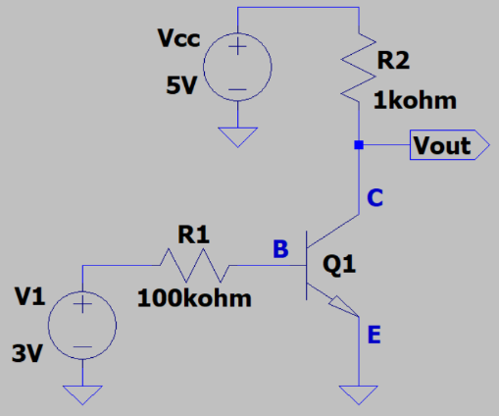
- Determine the base current I_{B} of Q1 in the adjacent circuit, given V_{BE} = 0.7 V. (Hint: Your answer should be between 20 and 30 μA.) (1 point.)
$$I_{B}=\frac{3-0.7 V}{100*{10}^{3}Ω}=23 μA$$
$$I_{B}=23 μA$$

v
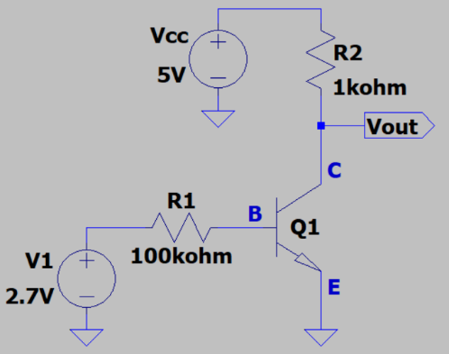
- Determine the collector current I_{C} of Q1 in the adjacent circuit given V_{BE} = 0.7 V and β = 100. (Hint: Your answer should be between 1.8 and 2.2 mA.)
(2 points.)

$$I_{B}=\frac{2.7-0.7 V}{100*{10}^{3}Ω}=20 μA$$
$$I_{C}=βI_{B}=100\left(20 μA\right)=2000 μA=2.0 mA$$
$$I_{C}=2.0 mA$$

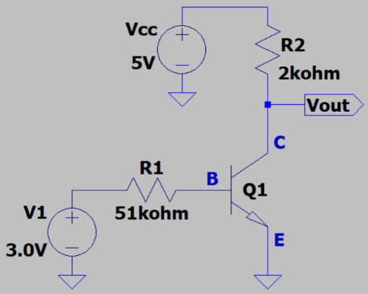
- Determine the following for the adjacent circuit given β = 53 for Q1. (Hint: I_{B} should be between 40 and 50 μA.) (3 points total.)

- V_{out}. (2 points.)
$$I_{B}=\frac{3-0.7 V}{51*{10}^{3}Ω}=45 μA$$
$$I_{C}=53\left(45 μA\right)=2.39 mA$$
$$V_{CE}=V_{o}=V_{CC}-V_{R2}=5V-2.39 mA\left(2kΩ\right)=0.22 V$$
$$V_{out}=0.22 V$$

- The region of operation for Q1, with the choices being Cutoff, Circuit Saturation, or the Active Region. (1 point.)
$$V_{CE}<0.3V→cuttoff$$

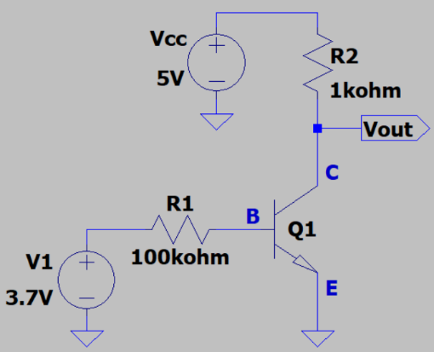
- Determine the following for the adjacent circuit given β = 100 for Q1. (Hint: I_{B} should be between 25 and 35 μA.) (3 points total.)

- V_{out}. (2 points.)
$$I_{B}=\frac{3.7-0.7 V}{100*{10}^{3}Ω}=30 μA$$
$$I_{C}=100\left(30 μA\right)=3.0 mA$$
$$V_{R2}=3mA*1kΩ$$
$$V_{BE}={V_{out}=V}_{CC}-V_{R2}=2 V$$
$$V_{out}=2 V$$

- The region of operation for Q1, with the choices being Cutoff, Circuit Saturation, or the Active Region. (1 point.)
$$V_{CE}=2 V>0.7 V→Active$$

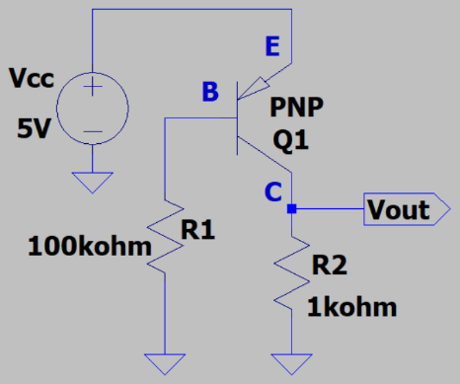
- Determine the base current I_{B} of Q1 in the adjacent circuit given V_{EB} = 0.7 V and noting that conventional current is considered negative when flowing out of a transistor terminal. (Hint: Your answer should have a magnitude between 40 and 50 μA.) (1 point.)
$$I_{B}=\frac{V_{CC}-V_{EB}}{R1}=\frac{5-0.7}{100 kΩ}=43 μA$$
$I_{B}=-43 μA$ (flowing out of base)

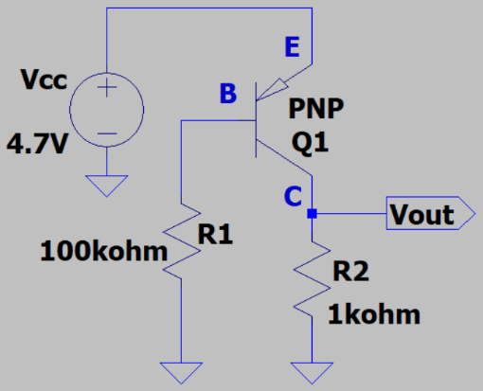
- Determine the collector current I_{C} of Q1 in the adjacent circuit given V_{BE} = 0.7 V, β = 110, and noting that conventional current is considered negative when flowing out of a transistor terminal. (Hint: Your answer should have a magnitude between 4.2 and 4.6 mA.) (2 points.)
$$I_{B}=\frac{V_{CC}-V_{BE}}{R1}=\frac{4.7-0.7 V}{100*{10}^{3}}Ω=40 μA$$
$$I_{C}=βI_{B}=110\left(40 μA\right)=4.4 mA$$
$$I_{C}=4.4 mA$$

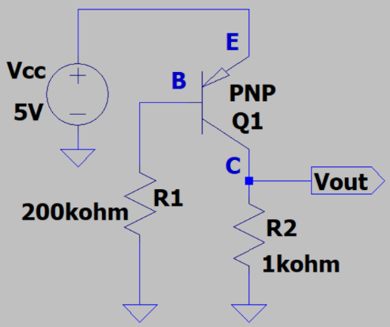
- Determine the following for the adjacent circuit given β = 95 for Q1. (Hint: ∣I_{B}∣ should be between 18 and 25 μA.) (3 points total.)

- V_{out}. (2 points.)
$$V_{BE}=0.7 V$$
$$I_{B}=\frac{5-0.7 V}{200*{10}^{3} Ω}=21.5 μA$$
$$I_{C}=βI_{B}=95\left(21.5 μA\right)=2.04 mA$$
$$V_{o}=I_{C}\left(R_{2}\right)=2.04 mA\left(1 kΩ\right)=2.04 V$$
$$V_{o}=2.04 V$$

- The region of operation for Q1, with the choices being Cutoff, Circuit Saturation, or the Active Region. (1 point.)
$$V_{CE}=V_{CC}-V_{O}=5V-2.04V=2.96V→active region$$

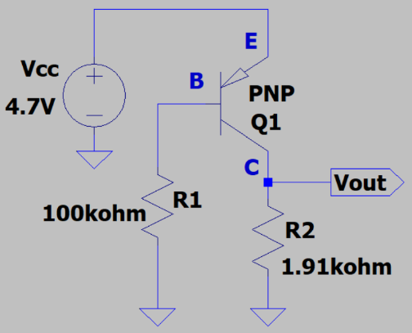
- Determine the following for the adjacent circuit given β = 60 for Q1. (Hint: ∣I_{B}∣ should be between 30 and 50 μA.) (3 points total.)

- V_{out}. (2 points.)
$$V_{BE}=0.7 V$$
$$I_{B}=\frac{4.7-0.7 V}{100 kΩ}=40 μA$$
$$I_{C}=βI_{B}=60\left(40 μA\right)=2.4 mA$$
$$V_{o}=I_{C}\left(R_{2}\right)-2.3 mA \left(1.91 kΩ\right)=4.58 V$$
$$V_{o}=4.58 V$$

- The region of operation for Q1, with the choices being Cutoff, Circuit Saturation, or the Active Region. (1 point.)
$$V_{CE}=5V-4.58 V=0.416 V>0.3→active$$

